Career Panel Expert Interviews

Interview Outline

Interviews conducted largely followed a scripted format. Naturally, some interviewees elaborated and at times included information outside the scope of the base questions. The general outline of interview questions is included below. The purpose of this document is to provide a bank of links for mentors to easily share interview segments they deem most relevant to their mentees.

The following questions were posed during the interviews:

- Who did you go to in order to seek new research opportunities?
- What got you into your chosen field?
- What comes to mind when the word “networking” is mentioned?
- What is the best piece of advice you received when you were thinking about getting into research?
- What was the toughest thing you had to overcome in your academic career?
- Who were the most influential people to your research, both inside and outside of your field?
- How did you feel when you were first introduced to reading research articles?
- Is public speaking easy for you?
- What has been your most spectacular failure, and what did you learn from it?
- What do you look for in undergraduate students you might bring into your research group?
- What broader impacts does your research have, e.g., community outreach? What kind of impact can you make through your research?
- What one piece of advice would you provide to undergraduates who are considering getting into research?

The following research veterans were interviewed for this project:

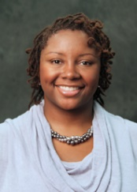 | Dr. LaShan Simpson  Assistant Professor, Mississippi State University  Biomedical Engineering  Agricultural and Biological Engineering
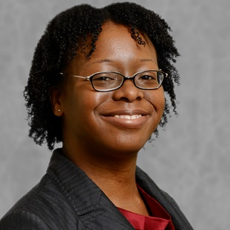 | Dr. Ericka Ford  Assistant Professor, North Carolina State University  Textile Engineering, Chemistry and Science Textile Technology
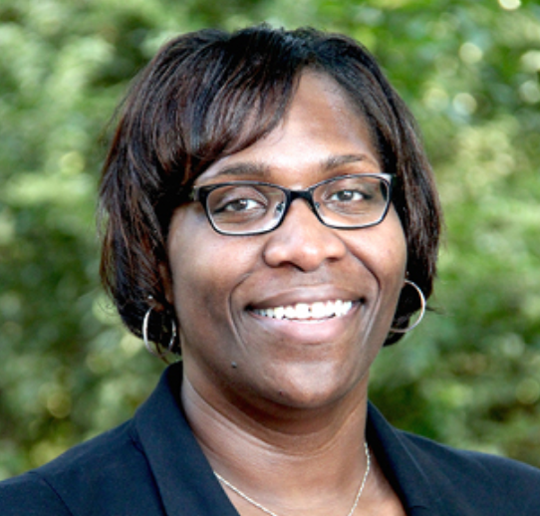 | Dr. Cheryl Gomillion  Assistant Professor, University of Georgia  School of Chemical, Materials, and Biomedical Engineering
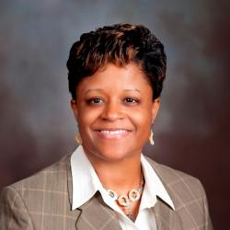 | Dr. Denise Simmons  Assistant Professor, Virginia Tech  Myers-Lawson School of Construction  Department of Civil and Environmental Engineering

Links to each expert’s complete interview can be found below:

- Dr. LaShan Simpson: https://www.youtube.com/embed/XGAmKZz_-Zg?rel=0
- Dr. Ericka Ford: https://www.youtube.com/embed/k36u6jKeyak?rel=0
- Dr. Cheryl Gomillion: https://www.youtube.com/embed/BMRNxv3fGUI?rel=0
- Dr. Denise Simmons: https://www.youtube.com/embed/ua2Zc_XsqBg?rel=0

NOTE: Some mentors may be able to get value from specific segments pertaining to particular topics without needing to share the entire videos. Below is a comprehensive list of timestamped links for the individual questions:

Who did you go to in order to seek new research opportunities (or what was the best piece of advice)?

- LaShan Simpson: https://www.youtube.com/embed/XGAmKZz_-Zg?start=30&end=71&rel=0
- Ericka Ford: https://www.youtube.com/embed/k36u6jKeyak?start=12&end=121&rel=0
- Cheryl Gomillion: https://www.youtube.com/embed/BMRNxv3fGUI?start=33&end=131&rel=0
- Denise Simmons: https://www.youtube.com/embed/ua2Zc_XsqBg?start=25&end=62&rel=0

What got you into your chosen field?

- LaShan Simpson: https://www.youtube.com/embed/XGAmKZz_-Zg?start=77&end=101&rel=0
- Ericka Ford: https://www.youtube.com/embed/k36u6jKeyak?start=131&end=166&rel=0
- Cheryl Gomillion: https://www.youtube.com/embed/BMRNxv3fGUI?start=132&end=168&rel=0
- Denise Simmons: https://www.youtube.com/embed/ua2Zc_XsqBg?start=86&end=369&rel=0

What comes to mind when the word “networking” is mentioned?

- LaShan Simpson: https://www.youtube.com/embed/XGAmKZz_-Zg?start=107&end=174&rel=0
- Ericka Ford: https://www.youtube.com/embed/k36u6jKeyak?start=171&end=234&rel=0
- Cheryl Gomillion: https://www.youtube.com/embed/BMRNxv3fGUI?start=172&end=255&rel=0
- Denise Simmons: https://www.youtube.com/embed/ua2Zc_XsqBg?start=387&end=500&rel=0

What was the toughest thing you had to overcome in your academic career?

- LaShan Simpson: https://www.youtube.com/embed/XGAmKZz_-Zg?start=178&end=255&rel=0
- Ericka Ford: https://www.youtube.com/embed/k36u6jKeyak?start=240&end=325&rel=0
- Cheryl Gomillion: https://www.youtube.com/embed/BMRNxv3fGUI?start=261&end=291&rel=0
- Denise Simmons: https://www.youtube.com/embed/ua2Zc_XsqBg?start=507&end=655&rel=0

Who was the most influential person for you, both inside and outside of your field?

- LaShan Simpson: https://www.youtube.com/embed/XGAmKZz_-Zg?start=262&end=334&rel=0
- Ericka Ford: https://www.youtube.com/embed/k36u6jKeyak?start=331&end=387&rel=0
- Cheryl Gomillion: https://www.youtube.com/embed/BMRNxv3fGUI?start=301&end=382&rel=0
- Denise Simmons: https://www.youtube.com/embed/ua2Zc_XsqBg?start=668&end=784&rel=0

How did you feel when you were first introduced to reading research articles?

- LaShan Simpson: https://www.youtube.com/embed/XGAmKZz_-Zg?start=339&end=425&rel=0
- Ericka Ford: https://www.youtube.com/embed/k36u6jKeyak?start=398&end=462&rel=0
- Cheryl Gomillion: https://www.youtube.com/embed/BMRNxv3fGUI?start=391&end=488&rel=0
- Denise Simmons: https://www.youtube.com/embed/ua2Zc_XsqBg?start=809&end=935&rel=0

Is public speaking easy for you?

- LaShan Simpson: https://www.youtube.com/embed/XGAmKZz_-Zg?start=432&end=466&rel=0
- Ericka Ford: https://www.youtube.com/embed/k36u6jKeyak?start=467&end=500&rel=0
- Cheryl Gomillion: https://www.youtube.com/embed/BMRNxv3fGUI?start=494&end=559&rel=0
- Denise Simmons: https://www.youtube.com/embed/ua2Zc_XsqBg?start=944&end=1002&rel=0

What do you look for in undergraduate students you might bring into your research group?

- LaShan Simpson: https://www.youtube.com/embed/XGAmKZz_-Zg?start=476&end=515&rel=0
- Ericka Ford: https://www.youtube.com/embed/k36u6jKeyak?start=522&end=574&rel=0
- Cheryl Gomillion: https://www.youtube.com/embed/BMRNxv3fGUI?start=578&end=679&rel=0
- Denise Simmons: N/A

What has been your most spectacular failure, and what did you learn from it?

- LaShan Simpson: https://www.youtube.com/embed/XGAmKZz_-Zg?start=522&end=587&rel=0
- Ericka Ford: https://www.youtube.com/embed/k36u6jKeyak?start=580&end=625&rel=0
- Cheryl Gomillion: https://www.youtube.com/embed/BMRNxv3fGUI?start=687&end=743&rel=0
- Denise Simmons: https://www.youtube.com/embed/ua2Zc_XsqBg?start=1009&end=1133&rel=0

What broader impacts does your research have, e.g., community outreach? What kind of impact can you make through your research?

- LaShan Simpson: https://www.youtube.com/embed/XGAmKZz_-Zg?start=595&end=721&rel=0
- Ericka Ford: https://www.youtube.com/embed/k36u6jKeyak?start=655&end=729&rel=0
- Cheryl Gomillion: https://www.youtube.com/embed/BMRNxv3fGUI?start=759&end=815&rel=0
- Denise Simmons: https://www.youtube.com/embed/ua2Zc_XsqBg?start=1150&end=1273&rel=0

What one piece of advice would you provide to undergraduates who are considering getting into research?

- LaShan Simpson: https://www.youtube.com/embed/XGAmKZz_-Zg?start=730&end=779&rel=0
- Ericka Ford: https://www.youtube.com/embed/k36u6jKeyak?start=738&end=766&rel=0
- Cheryl Gomillion: https://www.youtube.com/embed/BMRNxv3fGUI?start=828&end=868&rel=0
- Denise Simmons: https://www.youtube.com/embed/ua2Zc_XsqBg?start=1288&end=1378&rel=0

