MODULE: EXPECTATIONS AND PROGRAM OVERVIEW
OVERVIEW

Learning Objectives
Note – Each Module Workbook will contain this element. The Learning Objectives section will list the outcomes of the module, or what it is that you will be learning.

At the conclusion of this module, you will be able to:
- [Interpretation] Define the expectations for mentors and mentees in a research program
- [Comprehension] Describe the big picture of research
- [Evaluation] Evaluate examples of email etiquette to identify ‘good’ and ‘bad’ practices
- [Evaluation] Generate a schedule of how you manage your time during an average day and evaluate the efficiency of how your time is used.
- [Comprehension] Explain how a mentee’s project fits within the big picture of research
Materials for this Module
Note – Each Module Workbook will contain this element. Be sure that you locate and review each item listed in the Materials section of each module to ensure you have thoroughly completed each module. Your mentor may also revise materials in any particular module in the case that more pertinent materials are available for your area(s) of study.

- Email Etiquette Handout
- Time Management Handout

Introduction
Note – Most Module Workbooks will include a brief introduction or overview to the module topic. These are meant to provide a quick primer on the content and why it is important to your research experience.
Before you get started working with your mentor, we want to explain to you the purpose and drive of this research program. We start with the he simple question “Are all of the Answers Found in a Textbook ?”
NO! Sometimes no one has thought to ask a particular question. Sometimes no one could determine how to answer a particular question. We need RESEARCH to answer new and nagging questions.

What is Research?  - The search for knowledge or any systematic investigation to establish facts [1]  - Scholarly or scientific investigation or inquiry [2]  - Research means a systematic investigation, including research development, testing and evaluation, designed to develop or contribute to generalizable knowledge. [3]  [1] http://en.wikipedia.org/wiki/Research  [2] http://education.yahoo.com/reference/dictionary/entry/research  [3] US Government Code of Federal Regulations 45 CFR § 46.102.l | 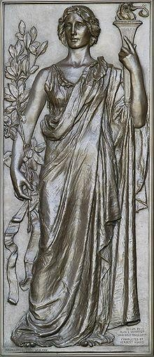  Research helping the torch of knowledge (1896). Library of Congress Thomas Jefferson Building, Washington, D.C.
What is Research? (some practical thoughts)
- Critically examining current ideas in your “field”
- Understanding existing ideas, testing and formulating new principles in order to improve the discipline/field
- Thinking “outside the box” to find new solutions to existing problems or to create new devices
- Creative thinking example: Two people playing chess, 5 games played, each won 3 games. How could this be? (Answer: They are not playing each other!)
- Research question examples: What causes a specific disease? What is the cure? What is the community attitude toward an issue? What are the strengths of a specific service?
Vocabulary of Research:
- Hypothesis: a statement that provides an explanation for why or how something works, based on facts (or some reasonable assumptions), but that has not yet been specifically tested.
- Objective: describes concisely what the research is trying to achieve. It summarizes the accomplishments a researcher wishes to achieve through the project and provides direction to the study.
- Engineering Methods: focuses on "the design, construction and evaluation of methods, techniques and support tools for information systems development".
- Scientific Methods: involves formulating hypotheses, via induction, based on such observations; experimental and measurement-based testing of deductions drawn from the hypotheses; and refinement (or elimination) of the hypotheses based on the experimental findings.
- Literature: A scholarly, critical study of published literature, generally for analysis purposes.
- Experiment: A study carried out to support or refute a hypothesis.
- Conclusion: A proven theory as a result of a specific experiment.
- Synthesis: Combining separate elements to form a conclusion.
Types of Research:
- Basic Research: Acquiring new knowledge of the underlying foundation of phenomena and observable facts. It is not directed to a particular application or commercial use.
- Applied Research: Directed primarily towards a specific practical aim. It applies basic research findings to discovery of new knowledge with commercial application.
- Experimental Development: Systematic work, drawing on existing knowledge gained from basic research and/or practical experience. It is the directed production of new materials, products, or devices to install new processes, systems and services, or significant improvement of useful products, services, processes, or methods. The design and development of prototypes, materials, devices, and systems.
What is the Purpose of Conducting Research?
- To understand past behaviors, to avoid repeating negative patterns, and to encourage good behaviors.
- To maximize productivity, to minimize costs and time.
- To better understand the world.
- To improve the quality of human life.
Who Conducts Research?
- Administrators, supervisors, managers
- Nurses, doctors, social workers
- Salespeople, marketers
- Scientists, engineers, designers
- Teachers
- Students
- We all do!
Who Funds Research at Universities?
- Government agencies such as the National Science Foundation (NSF), Department of Defense, etc.
- Companies such as Mars, Publix, Cargill, General Motors, etc.
- Nonprofit organizations such as the Multiple Sclerosis Society, American Heart Association, etc.
- Individual donors
Research Laboratory at a University:
- A research laboratory is a place dedicated to conducting experiments. This includes the equipment, people, materials, and supplies.
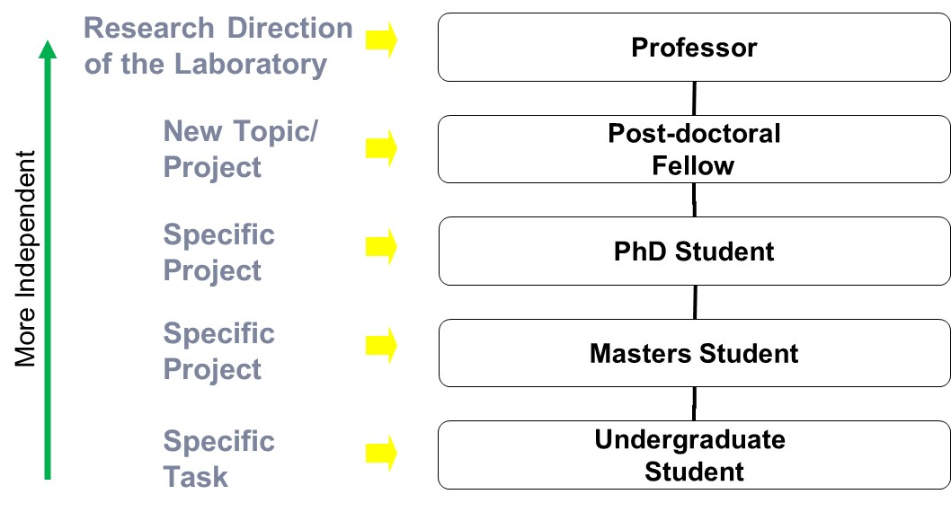
Creativity and Innovation in Research:
Research creativity and innovation occur with input from people with differing perspectives. A successful project requires a group that has good leaders, good followers, good listeners, good talkers, and good facilitators. People are different! Capitalize on technical, cultural, and social diversity.
Undergraduate Research:
The laboratory experience is an important part of your learning. It can help you become comfortable talking about a technical topic, open your horizons to career opportunities, create a network of people who can help you in your career, improve your problem-solving skills and technical skills, and allow you to make societal impact.
Working as an undergraduate researcher can be difficult at times but will certainly be rewarding. Remember to always be open to working and learning as much as you can. This is an opportunity that will help you learn how to discover things on your own and develop the ability to be an independent worker, which your future employer (whether that be in graduate school or in an industry position) will be impressed with. The goal of this program is to provide you with a foundation for professional and career development that can coordinate with the design and research that you do for your mentor. Always remember to work hard and don’t be afraid to ask questions.
The research you will conduct is not an isolated experience… it has the potential to influence fellow researchers and the public. Throughout these modules, you will learn the various modes of disseminating research results to scientists and non-scientists.

The following short sections appear only in this Expectations and Overview Module. They are meant to introduce you to general guidelines that will be applicable to your research and design experience, as well as your overall college experience. Please review below: Expectations

Expectations
Expectations of Mentees:
  - To be on time
  - To use good lab/safety practices when conducting experiments
  - To properly document all experiments and literature research
  - To be an awake, engaged, team player
  - To complete all homework assignments and professional development activities
Expectations of Mentors:
  - To be approachable and easy to contact
  - To be responsive
  - To be knowledgeable
  - To be helpful
  - To adequately prepare for weekly lab work and professional development activities

Laboratory & Safety Guidelines
The first criteria for a successful experiment are that no people were injured, and no equipment was damaged. A well-run laboratory will have carefully developed procedures to ensure safety and quality of results. We start with the idea that ALL mentees can and should learn science by conducting research investigations, that is why you are here. The start of this journey is to step into the laboratory understanding procedures and protocols:
  - Lab safety is critical, and mentees should learn to proceed with caution.
  - Each discipline and laboratory setting have their own set of hazards.
  - Follow closely the safety training requirements given by lab managers and mentors.
  - Speak up if you feel unsure or feel safety guidelines are not being followed.
  - Correct documentation and certification are critical steps to complete prior to working in the lab.

Assignment(s) for this Module
Note – Each Module Workbook will include this element. Most modules have at least one or two activities or
deliverable that will be used to illustrate your mastery of the learning objectives. Each module’s assignment
list will also include a ‘Five-Minute-Reflection’ that will help seed the discussions with your mentor. Along with materials, your mentor may also tailor the module assignments to best suit the needs for your area(s) of study.

Email Etiquette Activity:
Communication is an essential part of research, collaboration, and academic and professional life. Email is an efficient and effective communication tool. However, it can also be easy to neglect professionalism while using such a ubiquitous communication method. As researchers, mentees, colleagues, and professionals, it is important to use email in an appropriate manner. Strong email etiquette can lead to effective collaboration and communication. Poor etiquette can affect perceptions and yield unsatisfactory results. Review the associated handout on email etiquette and be sure to always consider best practices in all communication. Read Handout 1 “Email Etiquette” Mentors and mentees should discuss examples of their own experiences with “good” and “bad” email etiquette examples. Identify elements that contribute to good and bad email practices.
Compose an email message to your research mentor requesting a meeting to discuss a research article that you have been reading. Below is a poor attempt. What is wrong with the below?
Hey Ms. Smaith,
i didn’t have time to read the article u sent me…can u tell me what u thought i needed to know?
Billy-Bob
Deliverable 1: Document your revised email you composed.

Time Management Activity:
Review the Handout 2 “Time Management”. Consider how you use your time on a typical day. Complete the matrix provided in the handout and evaluate your own time management practices. The last page of the handout provides a completed sample matrix.
Deliverable 2: Document your responses from the Time Management activity (Handout 2).
Five-Minute Reflection:
- Come up with one question to discuss with your mentor (maybe a concept you are unclear on, something you found interesting, etc.).
- What information did you feel was the most informative? Least?
- Briefly describe your mentor’s research.
- What are your three goals for this semester?
Deliverable 3: Document your responses to the Five-Minute Reflection.

Mentee Deliverables:
- Deliverable 1: Document your revised email you composed.
- Deliverable 2: Document your responses from the Time Management activity (Handout 2).
- Deliverable 3: Document your responses to the Five-Minute Reflection.

Discussion with Mentor:
- Preference for correspondence (i.e. calling, office/Zoom meetings, texts, email)
- Big picture of research
- How project fits within big picture
- Relevant research articles that the group has previously published or are relevant to research topic
- Safety training requirements
- Goals and evaluation of goals – rework if necessary
- Five-Minute Reflection

Summary
  - 99% of your time will be spent on logistics and 1% on the “glamorous” part
  - Being a good researcher has more to do with motivation and tenacity than with book smarts
  - Be open minded and creative – if it’s already written in a book, it’s probably not research
  - Research experiences will expand your mind and your opportunities

Checklist
Note – Each Module Workbook will contain this element. As you review the materials for each module and prepare for your discussion(s) with your mentor, use the Checklist to ensure thoroughness.

Prior to meeting with mentor:
- Review Handout 1: Email Etiquette
- Review Handout 2: Time Management
- Review Handout 1: Email Etiquette Activity
- Complete Handout 2: Time Management Activity
- Complete Five-Minute Reflection
- Set up a recurring (e.g., weekly) time when you and your mentor can meet

