Types of Research Articles
Three main types of articles:
- Experimental Articles
  - Experimental testing
  - Scientific communication about personal/lab group experiments
  - Experimental methodology
- Meta-Analysis Articles
  - Combination of multiple experimental results
    - Commonly from different groups/labs
  - Secondary data analysis to find trends
- Review Articles
  - Summary of research data from a particular topic
    - Scientific communication analyzing others’ experiments
  - Meant to provide reader general overview of “state-of-the-field”
  - Can serve as starting point for exploring literature
  - Meant to give big picture of research area, may exclude some details
  - Components
    - Abstract
    - Introduction including statement of purpose
    - Relevance of particular research area
    - Breakdown of specific research questions
    - Figures that are examples of representative work
    - Discussion/future directions of research area
    - References
  - Why do we need review articles?
    - Reviews help us to avoid having to reinvent the wheel
    - Can be used as a map through many experimental articles that can be found on a subject
    - Help point to “holes” in the literature—areas for improvement

Sources of Information
Who creates and organizes articles? Anyone! You as a mentee must learn to identify the sources of information for the article that you are reading. Some sources of information are:
- Government
- Companies
- Individuals
- Clubs
- Universities
- Standard Organizations
- Professional Societies
- Technical Societies
As the figure shows, many organizations create and publish information. The trustworthiness of an article or publication is related to trust in the organization and how the sources distribute “products”.
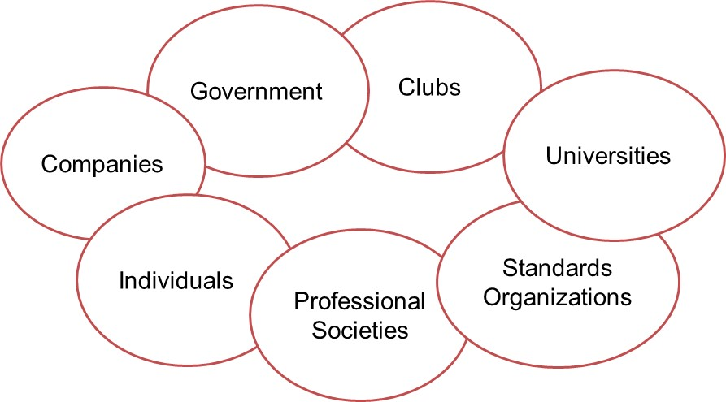

A particularly important source of information is a technical society. A technical society comprises members in a particular field who work together to share information. You may already belong to the student chapter of a technical society.
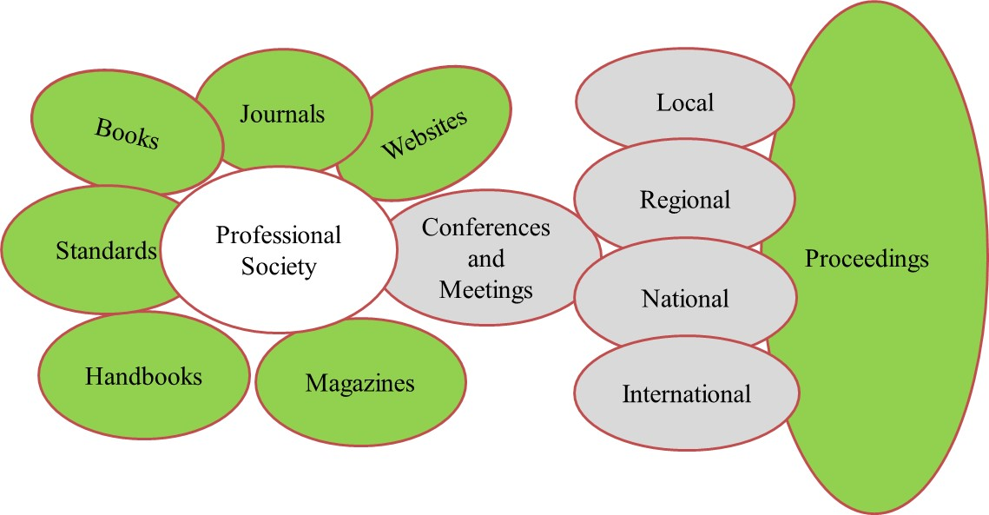

Summary of Sources of Information and Research Articles
