Module: Laboratory Readiness

OVERVIEW

Learning Objectives

At the conclusion of this module, you will be able to:
- [Interpretation] State the importance of laboratory safety to the process of research
- [Interpretation] Explain the importance of keeping a laboratory notebook, identify elements that should be included, and discuss when and how entries should be made
- [Application] Review a sample laboratory notebook entry for proper formatting and completeness

Materials for this Module
- Handout 1: Laboratory Notebook
- Handout 2: Laboratory Notebook Activity
- Handout 3: General Safety Activity

Introduction
The first criterion for a successful experiment is that no people were injured and no equipment was damaged. A well-run laboratory will have carefully developed procedures to ensure safety and quality of results. We start with the idea that ALL students can and should learn science by conducting laboratory investigations, that is why you are here. The start of this journey is to step into the laboratory understanding procedures and protocols:
- Lab safety is critical, and you should learn to proceed with caution.
- Each discipline and laboratory setting has its own set of hazards.
- Follow closely the safety training requirements given by lab managers and mentors.
- Correct documentation and certification are critical steps to complete prior to working in the lab.

Research
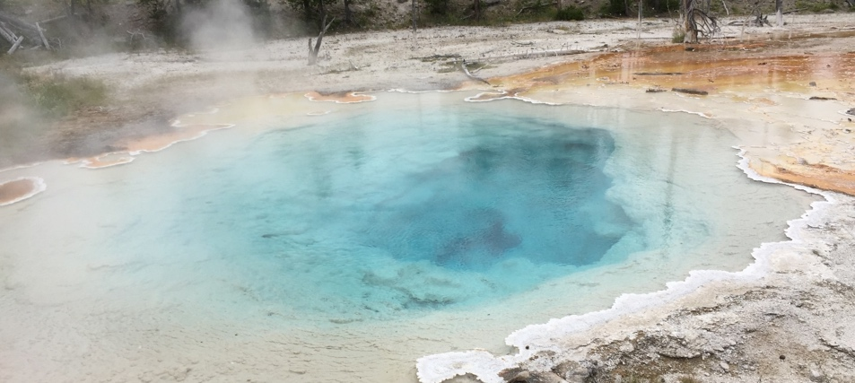
Photo credit: Dr. Karen Burg

Basic research is often in pursuit of knowledge without a clear application. It is often criticized in the general public as wasteful or frivolous. But sometimes, we learn more than we expect …
Dr Tom Brock, a microbiologist, visited the thermal pools at Yellowstone National Park. Different temperature pools have different bacteria and different colors. When Dr. Brock visited the pools in 1964 he recognized that it was remarkable that they survived in the high temperatures (to above 100C, the boiling temperature for water). He returned to collect samples and discovered a whole class of high-temperature bacteria called hyperthermophiles. The work in Yellowstone was ultimately funded by the National Science Foundation, but travel to the park was often labeled a “vacation”. He shared his work with others, research became focused on the enzymes that keep working in high temperatures. Enzymes from other organisms can't tolerate such heat. Understanding of this mechanism supplied the enabling technology for polymerase chain reaction – PCR – which laboratories around the world are using to detect the virus that causes COVID-19.
In this case an interesting question -> basic research (what was in the pools) -> basic research (how they survive) -> applied research (using the enzyme in PCR) -> development (apply PCR to COVID-19 testing).
… no one imagined the impact that this basic research would have over 50 years later!
It’s a good thing Dr. Tom Brock documented all his findings in a laboratory notebook, otherwise this very important, live-saving discovery would have been forgotten by now! In this module, you will learn how to make entries in your own notebook, so that any discoveries you make during your time in our lab can always be found.

Assignment(s) for this Module
Laboratory Notebook Activity:
Read over ‘Handout 1: Laboratory Notebook’ to learn the proper ways to document entries in your notebook. Next, refer to ‘Handout 2: Laboratory Notebook Activity’ for this assignment. You are provided two pages from an example laboratory notebook entry. Look over it for completeness and formatting. Would you be able to repeat this experiment based off the notes provided? What mistakes do you see? What improvements should be made?

Deliverable 1: Document your responses to the Laboratory Notebook Activity (Handout 2) by marking up the notebook pages to show your suggested improvements.

General Safety Activity:
Refer to ‘Handout 3: General Safety’ for this assignment. Familiarize yourself with the safety equipment and potential hazards in your own laboratory by making a sketch of the laboratory layout.

Deliverable 2: Document your responses to the General Safety Activity (Handout 3).

Five-Minute Reflection:
- What questions do you have about the importance of maintaining a laboratory notebook? How do you anticipate keeping a laboratory notebook for your own research?
- Come up with one question to discuss with your mentor (maybe a concept you are unclear on, something you found interesting, etc.)
- What information did you feel was the most informative? Least?

Deliverable 3: Document your responses to the Five-Minute Reflection.

Mentee Deliverables:
- Deliverable 1: Document your responses to the Laboratory Notebook Activity (Handout 2) by marking up the notebook pages to show your suggested improvements.
- Deliverable 2: Document your responses to the General Safety Activity (Handout 3).
- Deliverable 3: Document your responses to the Five-Minute Reflection.

Discussion with Mentor:
- Understand the importance and discuss techniques for making detailed entries in your lab notebook.
- Review the Laboratory Notebook Activity
- Discuss the General Safety Activity and the significance for this activity
- Discuss topics from the Five-Minute Reflection

Summary
- Make your highest priority ensuring the experiments are conducted safely, protecting people and property
- Document data and process parameters so that the experiment may be repeated and analyzed. The goal is to capture all the details that would be necessary to reproduce your experiment, ALL of the Details.
- Take plenty of photos and videos.

Checklist

Prior to meeting with mentor:
- Review Handout 1: Laboratory Notebook
- Complete Handout 2: Laboratory Notebook Activity
- Complete Handout 3: General Safety Activity
- Complete the Five-Minute Reflection

