Template for Planning an Interactive Demonstration Table

Who is your target audience and what do you expect them to learn?

Ex: Want undergraduate students with no science background to understand that medical research is ongoing and that new medical solutions will solve organ donation.

Sketch the area and traffic patterns. A photo may be useful. Indicate where the table will be located and where you will stand to attract participants and then give presentation (may not be the same location).

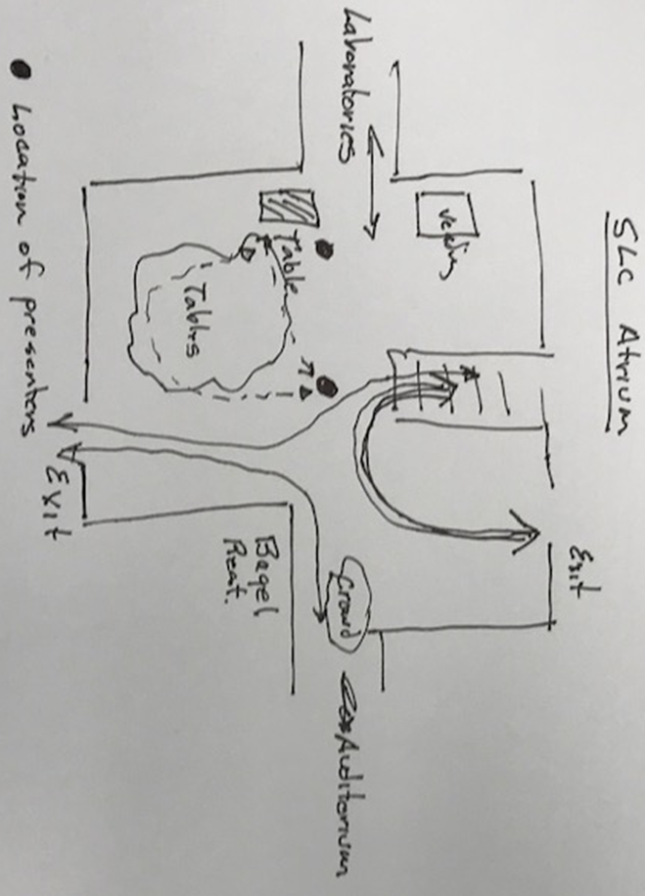

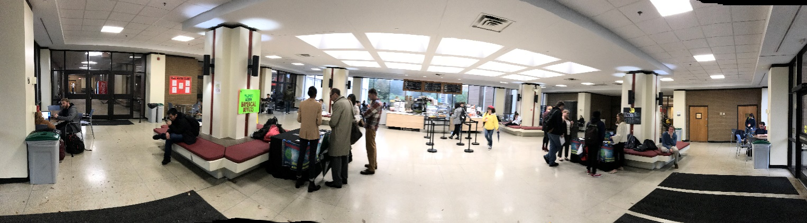

Sketch and label the presentation elements such as the table and signage.

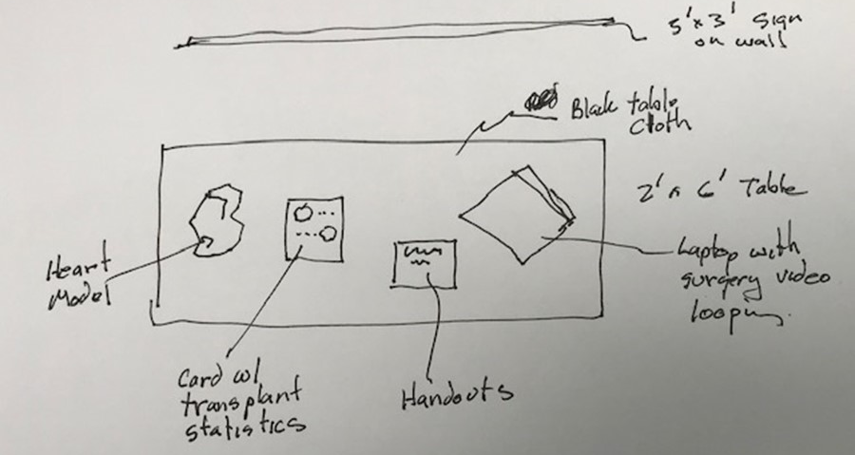

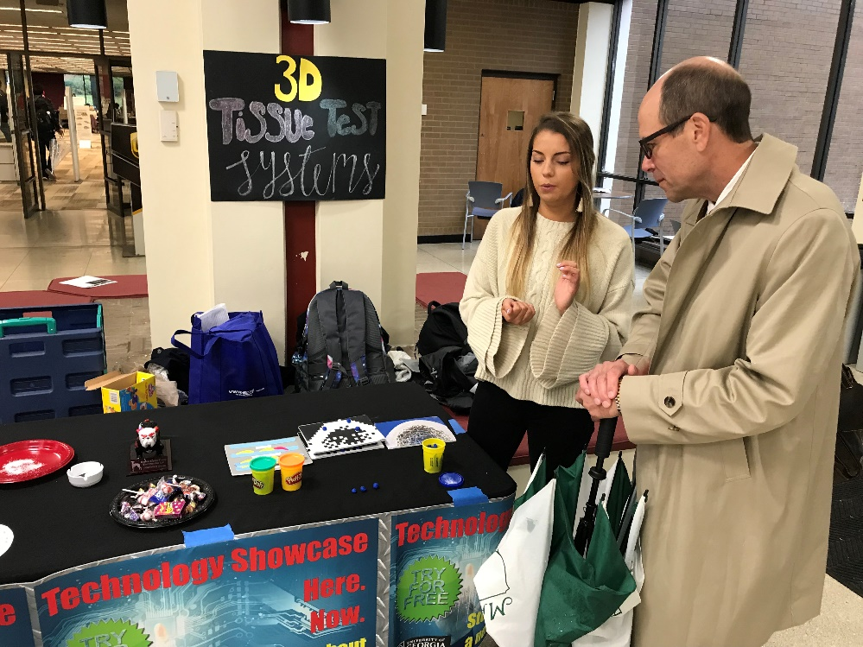

Engagement/Icebreaker/Lure: create a short question that will be used to engage a passer-by and persuade them to listen more.

Ex: Are you aware that scientists are growing new organs in the laboratory?

Create and practice your elevator speech

Materials checklist?
- Takeaways (physical artifact like a flyer)
- Tables and chairs
- Computer, 25’ cords, HDMI cable
- Poster, easy release tape

Define expectations for the event and measure how well you did?
Ex: We expect to talk with 50 people. Each presenter will have a clicker to count conversations. -> Measured40 people.
Ex: Want participants to be able to recite the first 4 digits of Pi. Verbally asked participant to recite at end of conversation. -> Measured that 25% of participants were able to recite the first 4 digits of Pi, 100% the first digit.

