Module: PRESENTATION SKILLS - InterACTIVE

OVERVIEW

Learning Objectives

At the conclusion of this module, you will be able to:
- Interpretation: Define categories that can be used to evaluate different types of presentations
- Interpretation: Identify strategies that can be used to deliver an effective interactive presentation
- Application: Deliver a strong interactive presentation on a chosen topic
- Evaluation: Critique your own presentation and those of your mentee cohorts

Checklist

Prior to meeting with mentor
- Review and practice tips on proper presentation technique
- Watch TED videos going over good and bad habits during presentations

Discussion with mentor
- Discuss presentation layout
- What mentor/ advisor looks for in presentations, specific points they like to point out
- Discussion of Five Minute Reflections

Mentee Deliverables
- Deliverable 1: Plan for an Interactive Demonstration. Bring the completed planning template to the next meeting and present your findings.
- Deliverable 2: Bring a printed copy of your responses to the Five-Minute Reflection to the next meeting.

Materials for this Module
- TED Talks playlist on public speaking – There are several good talks here that you are encouraged to peruse to gather inspiration and advice: https://www.ted.com/playlists/226/before_public_speaking
- Handout 1 - Template for Planning Interactive Demonstration Table. This is a list of things that need to be completed to deliver an effective interactive demonstration.
- Handout 2 - Evaluation rubric for an interactive presentation

Introduction to Presentation Skills
Presenting or public speaking is something that the majority of people do not enjoy. You have to learn to enjoy it. And the best way to do this is through practice, no matter how painful. There are some key points that can help you improve your presenting skills. Review the list of tips included below. Evaluate your own presentation skills and determine which ones you count as strengths and which ones you can improve.

General Tips
- Know your audience. What do they know? What would motivate them to learn something new?
- Take your time, don’t rush.
- Avoid shiftiness, plant your feet, don’t sway.
- Dress to impress (know the dress code).
- Don’t overwhelm your audience with information.

Tips for Delivering an Effective Interactive Demonstration
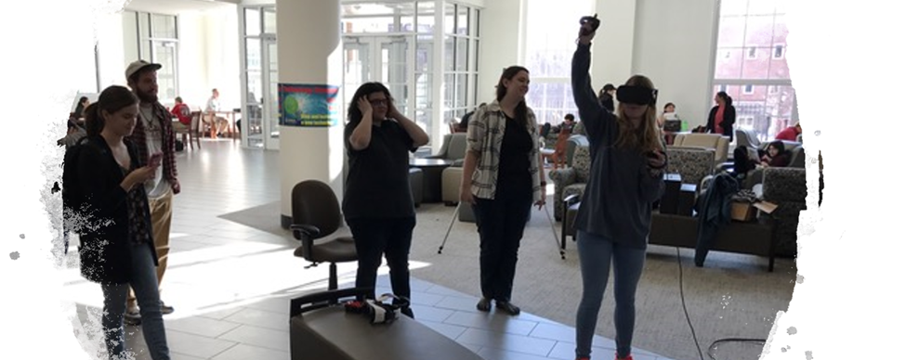
- Design signs, lighting, giveaways, etc. to attract attention and interest
- Visit the targeted space that you will be using, note traffic flow and space limitations, sketch the space layout, take photos of the space
- Script the interaction with the participant.
  - Engagement/Icebreaker/Lure to make them stop what they are doing, e.g. walking to class, and stop to talk with you. What will you say? How will they likely respond?
  - Ask them about their background (“what is your major”, “are you a graduate student”, etc.) and use this information to adjust your message to meet their knowledge level.
  - Prepare an “Elevator Speech” that delivers your message. Be ready to adapt to physical or verbal cues from the participant.
- The interaction is short (1 2 minutes), takeaway message must be very concise and meaningful to the participant.
- Tactile activity, like holding a tissue scaffold in participant’s hands, promotes interaction
- For a table display, plan layout. Use contrasting colors to make display elements easy to see. Practice your message with the table completely set up with display, use friends as pretend audience.
- A physical artifact such as a sticker or card may help reinforce your message.
- Define expectations for the event, determine how to collect “data”, and then make measurements to decide if it was effective. Planned to talk with 50 people and we talked with 60.

Assignment(s) for this Module

Assignment 1: Design an Interactive Demonstration
Consider how you could make an interactive demonstration to communicate your work to an audience who doesn’t expect a presentation. That is, you will set up a display such as a table and talk with passers-by about your science. This audience presents unique challenges as the target audience likely already has plans that you will delay and they are afraid of being stuck with a sales presentation. Consider how you will gain trust and attract participants, how you will teach them what you want them to know, and how will you measure if the event is a success. The handout at http://usasciencefestival.org/wp-content/uploads/2017/04/Tips-for-Booth-PDF-2018.pdf provides some more details on designing a display and an example for ink-jet printing.
Deliverable 1: Use Handout 1, “Template for Planning Interactive Demonstration Table”, to plan for an interactive demonstration about your research. Bring the completed planning template to the next meeting and present your findings including the icebreaker and elevator speech.

Five-Minute Reflection
Come up with one question to discuss with your mentor (maybe a concept you are unclear on, something you found interesting, etc.)

What information did you feel was the most informative? Least?

Funniest or most ridiculous thing you have seen someone else do in a presentation. Was it distracting or did it improve the talk?

List 3 things you can improve on with respect to presentation skills. List 3 things you feel you do well with respect to presenting.

Deliverable 2: Bring a printed copy of your responses to the Five-Minute Reflection to the next meeting

