How to Find National Science Foundation (NSF) Research Experience for Undergraduates (REU) Programs

Adapted from the Olin College Post Graduate Planning web site: http://www.olin.edu/pgp/docs/GettingAnREU.pdf

Step 1: Search for Current REUs

National Science Foundation REUs
Look up programs that have received funding from the National Science Foundation (NSF):
http://www.nsf.gov/crssprgm/reu/reu_search.cfm

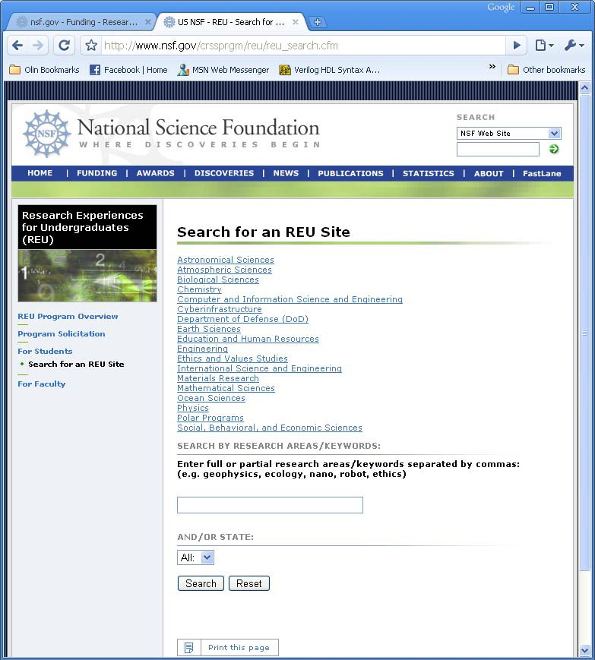

Main NSF REU web site

Click on the area of research that interests you, or use the keyword search to find more specialized results.

Other Summer Research

To find additional opportunities not funded by NSF, do a keyword search in a web browser. Type in your major or your specific area of interest and the year (2017) followed by “REU” or by “summer undergraduate research” or by the acronyms SURE (summer undergraduate research experience) or SURP (summer undergraduate research program).

Step 2: Explore your search results
As an example, here is a search for a mechanical engineering REU on the NSF web site:

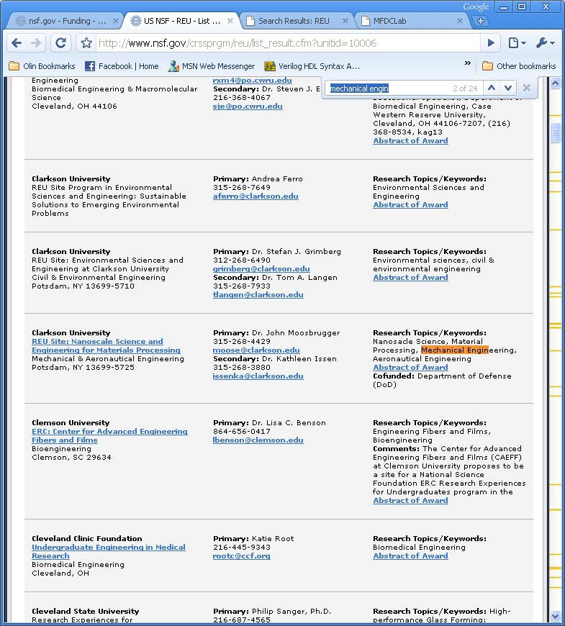

NSF site search results

Click on the link; if for some reason the link doesn’t work, go to the sponsor university’s main web site. From there, search for REU or Mechanical Engineering Research to find the web page. Some schools (like the Clarkson U. example below), have all their REU websites listed on one page, but usually you have to look department by department to find the mechanical engineering REUs vs. the math REUs vs. the materials science REUs.

Read the descriptions of the research at each site to find those that sound interesting to you. You may also want to think about whether this is a school that you would like to attend for graduate studies.

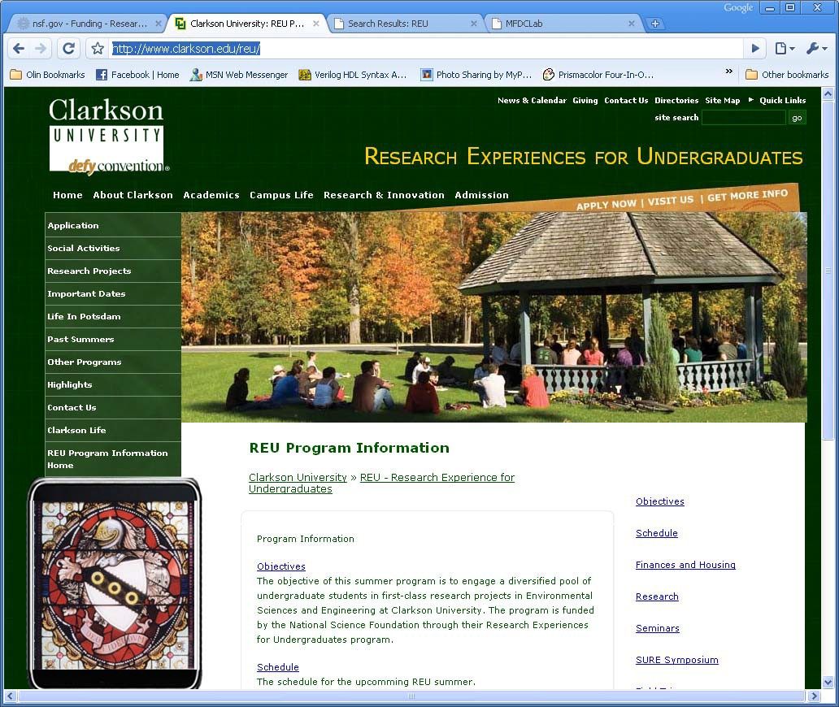

Clarkson College’s web page for all REUs at that university

Step 3: Apply

The more REUs you apply to, the better your chances! On each one, check out the “eligibility” section to make sure you have the minimum requirements: GPA, major, class standing (sophomore, junior, senior), citizenship, etc. If you don’t have the minimum requirements it is probably not worth your time to apply.

Also check the deadline to make sure it hasn’t passed. Deadlines can be as early as January and as late as March.

Then note the application requirements. They are usually:

1. REU Program Application Form
2. Two letters of reference, either uploaded by the person writing or mailed in a sealed and
signed envelope
3. Official undergraduate transcript(s) – you have to order this from the University registrar
4. Statement of interest in the program (sometimes called the” personal statement”), limited
to two pages, where you talk about relevant experiences and why you would make a s successful researcher)

Usual Timeline:

Thanksgiving The websites should be updated with 2019 information and applications.

Before Winter Break Ask for letters of recommendations

Winter Break Apply for at least six REUs (more would be preferable!)
Send reminders to recommenders for REUs with an early (before
January 15th) due date

Spring Semester Make sure recommendations have been sent

You could start receiving responses from the programs as early as February. Don’t despair though, mid- to late March, even mid- April is also reasonable.

