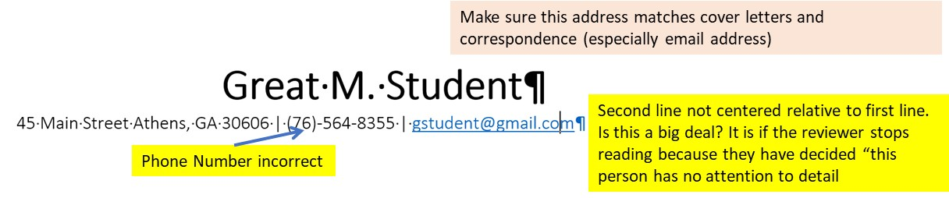
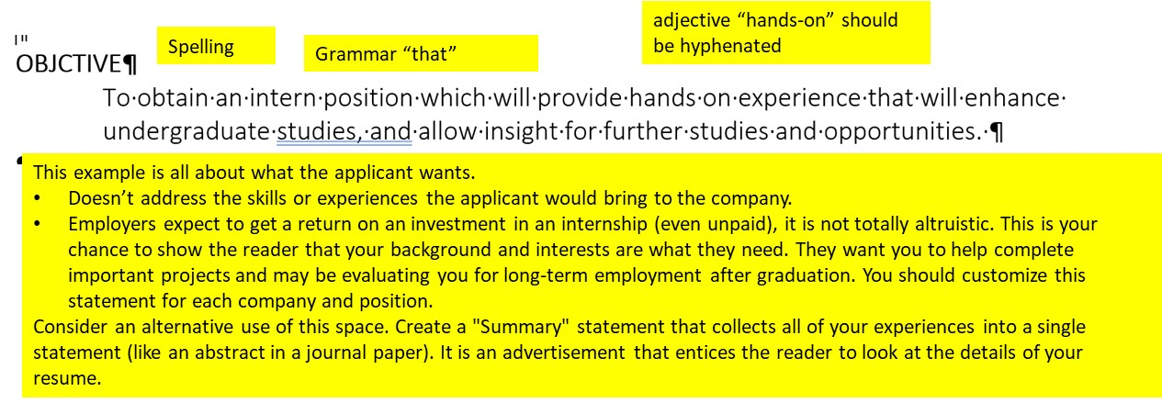
EDUCATION
B.S. Electrical Engineering (Biomedical Focus) Expected Graduation May 2021
Superior University, College Town, GA
GPA 3.21/4.00
