MODULE: SWOT ANALYSIS (STRENGTHS, WEAKNESSES, OPPORTUNITIES, & THREATS)

OVERVIEW

Learning Objectives

At the conclusion of this module, you will be able to:
- [Interpretation] Define the elements that make up a SWOT analysis
- [Interpretation] Review a sample publication and its related sample SWOT analysis
- [Analysis / Application] Conduct a SWOT analysis on the research article you are studying
- [Evaluation] Create suggestions for future research based on your SWOT analysis

Materials for this Module
- Handout 1: Sample Research Article (Note that the publication is also available at https://www.ncbi.nlm.nih.gov/pubmed/28986723 , but access will depend on your institution’s journal subscriptions.)
- Handout 2: Sample SWOT Analysis
- Handout 3: SWOT Worksheet

Introduction
What is a SWOT Analysis?
SWOT analysis is an approach to critically analyze your position from all directions by identifying the Strengths, Weaknesses, Opportunities and Threats associated with the initiative. A SWOT analysis is an evaluation tool used in a variety of settings (businesses, big projects, small projects, company strategic planning, research projects, career, personal life, etc.). A SWOT analysis can be used to evaluate a research project described in a journal publication. It is often helpful for someone not involved in the project to perform the SWOT analysis as they will easily see the WOTs. Most projects have many SWOs but only one or very few Ts.
- Strengths: aspects of the project (or initiative/business/etc. being evaluated) that give it an advantage over others.
- Weaknesses: correctable aspects of the projects that place it at a disadvantage relative to others.
- Opportunities: elements or angles that are unrealized and could provide an advantage to the project.
- Threats: elements or realities that could cause irreversible, serious problems for the project. Threats are often hardest-to-address issues such as change in technology or new technologies that would render the current project obsolete.
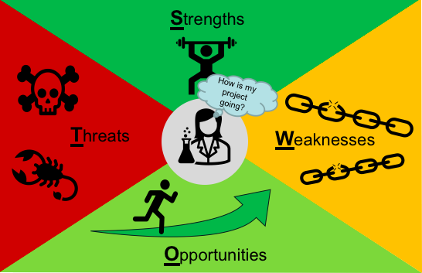

How do you decide if something is a threat? Something is a threat if the effects, exposures, and risk probabilities are collectively high.
- Effects: the damage that could be done
- Exposure: the number of times or amount of time the system is used
- Risk Probability: the likelihood of a negative event

Example Threat Assessment: A rattlesnake is a poisonous snake whose bite can have severe effects. This is an inherent property of rattlesnakes. If you are in a small room with a live rattlesnake, you have a high exposure. If you are moving around and disturbing the snake there is a high probability that you will get bitten. The rattlesnake is a threat because the effects, exposure, and risk probability are all high.
Same scenario, but now the rattlesnake is confined to a cage. It is the same rattlesnake as before and a bite can still have severe effects. However, now you are not exposed to the snake and the risk of being bitten by the snake is extremely low. The rattlesnake is not a threat because the exposure and risk probability are almost zero (unless you open the cage).
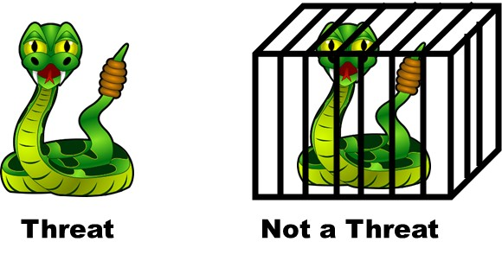
How to Develop a SWOT Analysis for a Research Project:
Determining the Strengths, Weaknesses, Opportunities, and Threats of previously conducted research is a great way to begin thinking about how your work can fit into the research field. Remember, all research has some kind of limitation. Your job is to discover what those limitations are and see if you can build on the concepts that other researchers have started. Most research studies are not based on crazy new ideas, they are iteratively built concepts on which a lot of people are building. So, to be able to build efficiently, it’s really helpful to analyze others’ papers and topics using a SWOT analysis by asking the following:
- Strengths - what are the positive features of the research?
- Weaknesses - what are the significant flaws or gaps in the work?
- Opportunities - what aspects of the work, either realized or not, might lead to future impact?
- Threats - what are the severe weaknesses that impinge on the future success of the research?
Example Using SWOT Categories on a Research Project: Imagine you are performing a SWOT analysis of your research project. Some sample observations are shown in the middle column below. The third column describes how the SWOT Item contributes to your understanding and management of the project.
Category | SWOT Item | Analysis
Strength | Our measurements provide 10% less variability than that of other groups. | This achievement may distinguish results as more accurate or may even lead to additional insights.
Weakness | The current approach requires much more calculation to reach the result than the current method. | While additional calculation could take more time and introduce error, it is likely that it would be solved through better software or automation.
Opportunity | It now appears that all cell types behave this way in response to a particular agent. | This may be a chance to expand the project to have more impact. (you could also see this as a strength).
Threat | We are using the ZZF corporation polymer since it is the only one available on the market. | If the ZZF company stops making this specific polymer is it the end of the project?

How to Develop a SWOT Analysis for a Research Paper:
- Strengths: First, define the strengths of the paper. What are the positive features of the research? Did the authors define the problem? Does their solution fit the problem? What did they do well?
- Weaknesses: What did they do poorly? Were their techniques effective? What are the significant gaps or flaws in the work?
- Opportunities: Assess if there are any opportunities that you could create from their ideas. Could different techniques be applied to the same concept? Are there any other ideas that are similar to this concept? What aspects of the work, either realized or not, might lead to future impact?
- Threats: Lastly, determine if there is any threat to the validity of the paper’s conclusions. Is there any reason to believe that this research is biased or skewed? Are their samples large enough?
Using SWOT Analysis to Sharpen Your Career Path:
A SWOT analysis can be used to help with decisions in your everyday life. Consider for a minute your career, think of at least one element for each of the SWOT categories.
Note that your analysis is based on your perceptions; in some cases your perceptions may reflect reality and in other cases they may not, it is tough to identify your own “blind spots”, i.e. points of which you are not aware but which are highly visible to others – to reveal some blind spots, ask your mentor to provide a SWOT for you!
- Strengths- What are you doing well…Planning? Exploring options? Making connections?
- Weaknesses - What skills are you lacking? What research experiences should you have by graduation?
- Opportunities – What else could you be doing? Is it really an opportunity or distraction from your main goals?
- Threats – What might happen that would require you to completely change your career
This is a tough, but useful, exercise. This is NOT a required activity for this module, but you should take the time to do a SWOT analysis of your career in your free time!

Assignment(s) for this Module

SWOT Analysis Activity:
Read the article provided in Handout 1 and review Handout 2 for a SWOT analysis example of that article. After you understand the analysis of this article, complete your own analysis of an article using Word document version of Handout 3 as a template. You can use an article you have already studied, or an article provided by your mentor.
Deliverable 1: Document your SWOT Analysis (Handout 3).

Five-Minute Reflection:
- There are four perspectives included in a SWOT analysis – does this give you a complete 360º view; if not, what perspective might be missing?
- Synthesize one question to discuss with your mentor (maybe a concept you are unclear on, something you found interesting, etc.).
- What information did you feel was the most informative in this module? Least?
Deliverable 2: Document your responses to the Five-Minute Reflection.

Mentee Deliverables:
- Deliverable 1: SWOT Analysis (Handout 3).
- Deliverable 2: Responses to the Five-Minute Reflection (Overview).

Discussion with Mentor:
- Application of a SWOT analysis to everyday research
- Application of a SWOT analysis to your personal life
- Five-Minute Reflection
Summary
- SWOT analysis means looking at yourself, your project, a company, a research paper, or project from four critical perspectives by identifying the Strengths, Weaknesses, Opportunities, and Threats.
- The SWOT analysis becomes a guide for planning and action. Use the strengths to take advantage of the opportunities, correct the weaknesses, and avoid the threats.

Checklist

Prior to Meeting with Mentor:
- Review Handout 1: Sample Research Article
- Review Handout 2: Sample SWOT Analysis
- Complete SWOT Analysis Activity
- Complete the Five-Minute Reflection

