Research Funding
We can think of research as a process as illustrated in the figure below. The inputs to the process are money, ideas, and needs. he outputs of the process are patents, new knowledge, and products. Companies, universities, government laboratories, private laboratories, and individuals perform the research. The main objective of this handout is to explain who funds research (like the work in the program you are currently participating) and why they fund research.

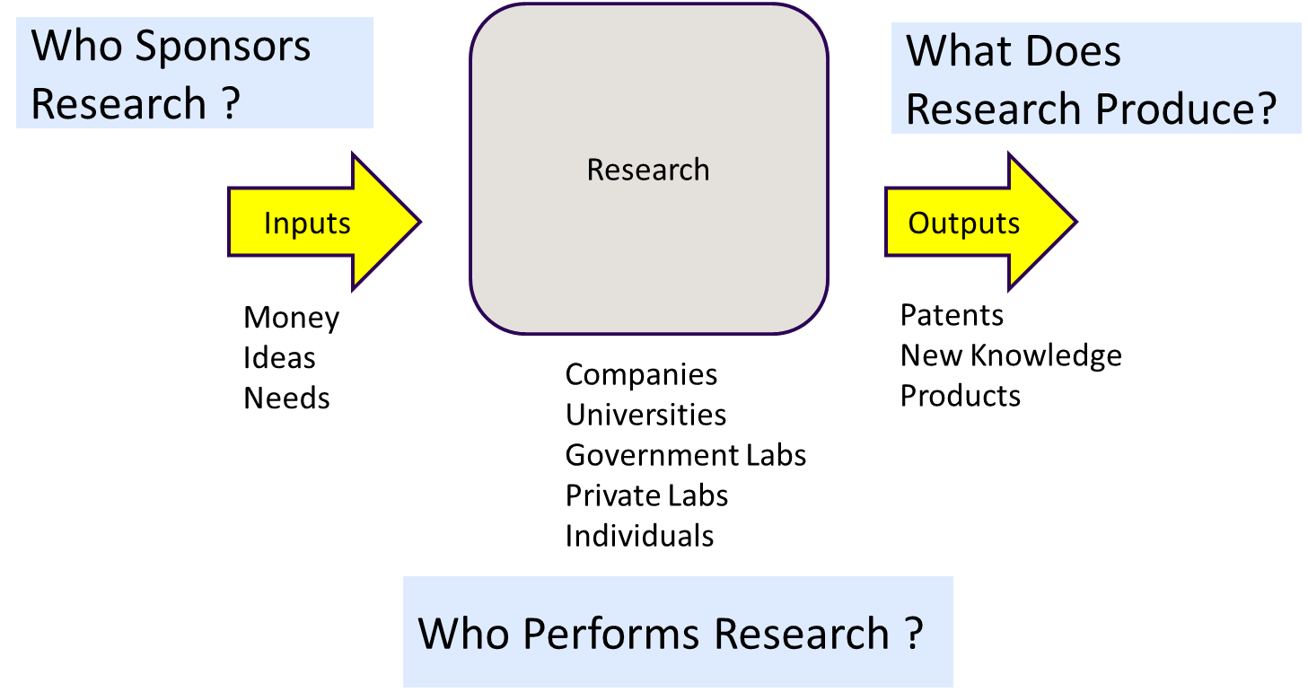

There are three types of research, each has different expectations (outputs) and purpose:
- Basic Research
  - Acquire new knowledge of the underlying foundation of phenomena and observable facts
  - Not directed to particular application or use
  - Example: Understand why leaves on trees turn orange in the fall.
- Applied Research
  - Original investigation to acquire new knowledge
  - Directed primarily towards a specific practical aim
  - Example: Understand why rubber oxidizes in order to build better tires
- Experimental Development
  - Systematic work, drawing on existing knowledge gained from research and/or practical experience.
  - Directed to producing new materials, products or devices, installing new processes, systems and services, or to improve substantially those already produced or installed.
  - Example: Design a new miniature antenna for tracking caterpillars
The percentage of funding dedicated to practical purposes, which will likely result in products, is the majority (~80% in the figure below) of all research money spent in the United States during a year.

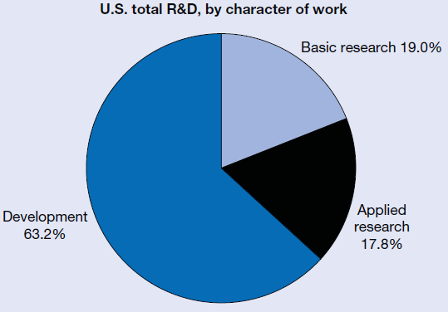

Groups will fund these research activities for the following reasons:
- Governments - basic research is presumed to be a "public good" whose benefits are shared by all.
- Governments – companies won’t fund basic research because it would be shared with competitors
- Companies – gain competitive edge
- Companies – develop new products
- Individuals – intellectual curiosity
- Foundations – solve specific problem/disease
- Governments - science is so expensive that private funding is insufficient.
- Governments – training
Business is the largest funder of research in the US. Above we said that ~80% of funding is directed toward making and designing products, applied and development research. The federal government funds most of the basic research.
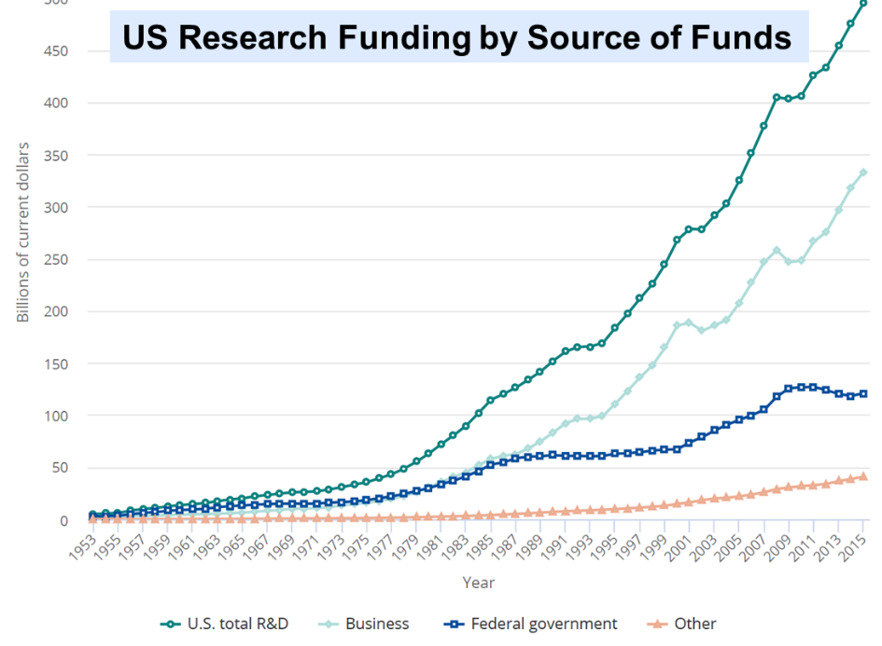

The majority of basic research is performed at universities and colleges as seen in the figure below. Companies do perform basic research for reasons such as recruiting, retaining, and training the best scientists.

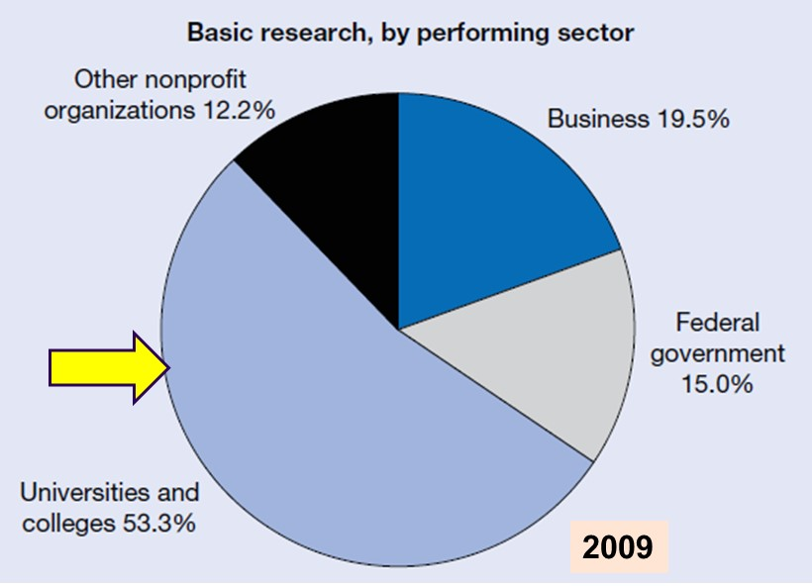

Figures below indicate that patents and papers are produced by US researchers.

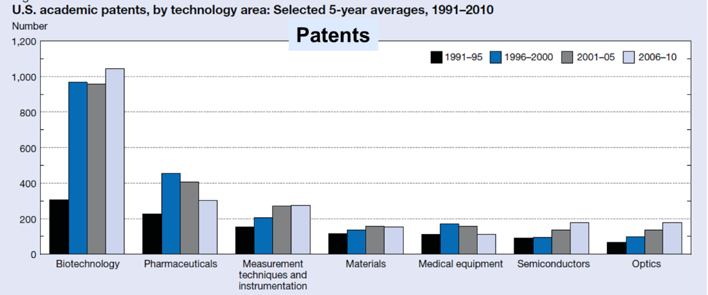

The building, faculty, support, supplies, and equipment in your current laboratory were supplied by an organization for a purpose. We are engaged in the research enterprise and it is important to understand who pays for the work we are doing and what are their expectations. Research is important to countries (the US Spent $500 billion in 2015), universities, and individual researchers. Funding is required to support the research as well as train new researchers.

